Problem 1.A

N = 2
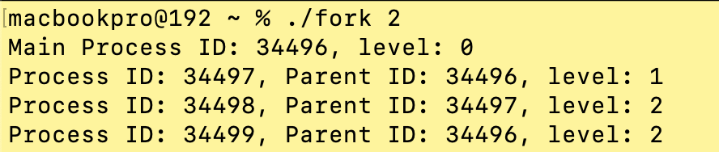

N = 3

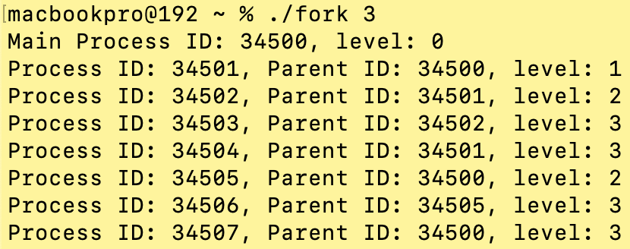

N = 5
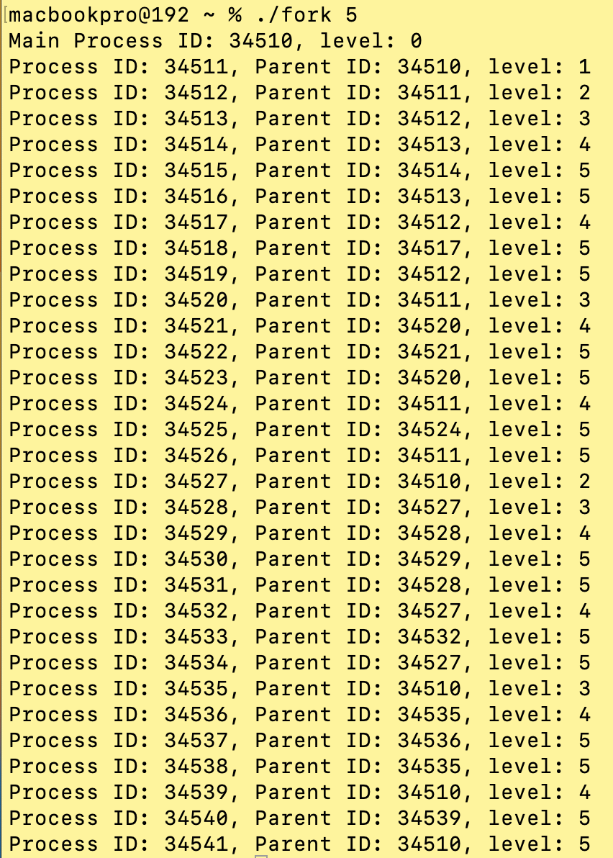

Problem 2

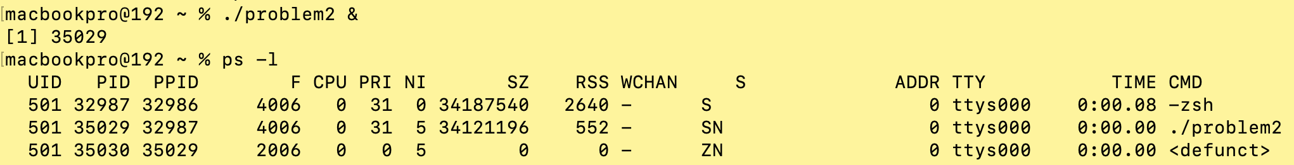

Results of ps -l command after 5 seconds

